|  |  |  |
| --- | --- | --- |
| **Date** |  |  |
| **Employee Number** |  |  |
| To,  The Manager |  |  |
| Bank Name |  |  |
| UAE |  |  |
|  |  | **Subject: Account Opening Form** |

Dear Sir/Ma'am,

This is to certify that the following personnel is employed with us.

We are under the instruction from him/her to credit the salary to their respective account with your bank

|  |  |  |  |  |  |  |  |
| --- | --- | --- | --- | --- | --- | --- | --- |
| Sl. No | Employee ID | Employee Name | Date Of Joining | Salary (AED) | Passport Number | Designation | Visa |
| 1 | Emp | Name | DOJ | Salary | Passport | Designation | Visa |

This letter has been issued at the request of the employee without any liability on the company. Please feel free to contact us if you require any further information.

Kind Regards,

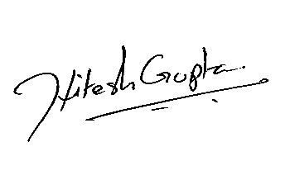





Hitesh Gupta

Associate Vice President- E-Care

*Account Opening Form*

*TASC-ECARE/SOP/EM-LM/008/F1(AO) Version: 01 | Date: April.2020*

*\*This is a system generated document. No physical signature is required.*